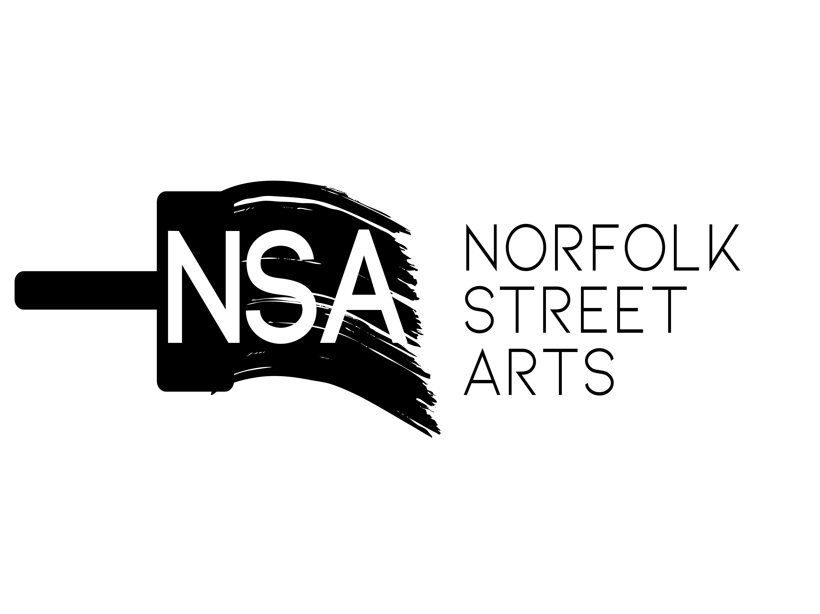

Exhibition Opportunity : Hills Heritage Responce

Fantastic Exhibition Opportunity Available at : 17/18 Waterloo Place - Hills Arts Centre

To kick off the first of our exhibitions programme we are looking for exciting work produced by artists from Sunderland who have been inspired by their memories of the former Hills book shop and arts supplier. Our first open call is for work which can sit alongside our heritage exhibition and will be digitally mapped by Art Matters Now and will be the first exhibition in our flagship space. This is one of four opportunities developed as part of our first Hills Programme.

Hills Arts Centre is Sunderland’s newest independent grass roots cultural hub. Hills will be our flagship venue with a bespoke high street, not for profit gallery space ran by Norfolk Street Arts which will sit alongside Grinder Coffee’s newsiest city centre venture equalling a social and cultural hub and the home of great art and great coffee.

We are looking for an artist to co-curate their work inspired by the heritage of the former Hills bookshop. We aren’t necessarily looking for new work for this exhibition, but we do want work which is reflective of the building and its memories / the artists memories of Hills, which will be displayed in a contemporary new space.

Norfolk Street Arts is delighted to offer this opportunity to an emerging practitioner giving them the the chance to develop their practice in generous exhibition space. The creative practitioner applying will need to set out a case for why the exhibition opportunity will develop their practice.

This project has been made possible through Arts Council England with support from our project partners.

Exhibition opportunity Info:
*Exhibition Fee - £700.00 (payable on completion of the exhibition on the conditions all the timeframes are met)
*This Solo Exhibition will sit along side our heritage programme exhibition.
- Installation date - 26-30 November 2021
- Private View Date - Dec 3rd

The practitioner will be required to:
Deliver the work proposed in their application. Use the exhibitions to promote their practice and the organisation.
Attend the private view and events associated with the exhibition.
Engage with the support provided by the partners and build their practice to achieve an early step in their career.

HOW TO APPLY :

Please fill in the attached form below and return it to: norfolkstreetarts@gmail.com

A Completed submission consists of:
*Completed Application form ( See below)
*Submission of at least one attachment of images as PDF
*Equal Monitoring Form

If shortlisted you may be asked to attend a meeting to discuss your application with a panel from the partnership organisations.

We regret we cannot provide feedback to unsuccessful applicants. To ensure fair process all of our open call will be selected by an independent body from our partnerships, such as Sunderland Culture, Sunderland University, MBC Arts Wellbeing and many more, We aim to have different partnerships select on differing open calls.

*Application deadline: 5PM 15th of November 2021

PART 1 – PERSONAL DETAILS

Name

Address

Date of Birth

Email Address

Contact Telephone

Website

Facebook page - Business only

Instagram

Where did you study

Year of Study

PART 2 – ABOUT YOU AND YOUR CURRENT PRACTICE AND WHY YOU WANT TO EXHIBIT AT HILLS

A: Please give details and background information about you, your practice and where you are now( max 500 words)

B: Why do you propose your work will best compliment our our hills heritage programme and be co-curated alongside it ? Tell us about your ideas, mediums and research ( Max 600 words )

PART 3 – YOUR PRACTICE AND DEVELOPMENT

C: Please give details on your practice, where you are at and how you intend to develop in the future and how the proposed subject above will help you achieve your goals (Max 400 words)

PART 4

Limit of two attachments Maximum.

* Attachment one - Must be images of the work proposed and saved as a PDF on one document.
8 Images Maximum.

* Attachment two - Can be either an artists statement or a reference. Must be saved as a word document.

